**Netflix Dataset Analytics Project**

**Introduction**

* **Domain: Entertainment and Streaming Services**
* **Problem Statement: How can Netflix use SQL-based data analytics to optimize its content strategy, improve user engagement, and identify global trends in content consumption?**
* **Objectives:**
  1. **Analysed Netflix's content catalogue for patterns and trends.**
  2. **Predict future content needs based on historical data.**
  3. **Provide actionable recommendations for content optimization and audience targeting.**

**Dataset Description**

* **Source of the Dataset: Netflix dataset collected from publicly available sources or Netflix reports.**
* **Number of Rows and Columns: The dataset contains [X rows] and [Y columns] (to be determined after loading the dataset).**
* **Key Variables and Descriptions:**
  + **type: Type of content (Movie or TV Show).**
  + **title: Title of the content.**
  + **director: Director of the movie or TV show.**
  + **country: Country of production.**
  + **date added: Date the content was added to Netflix.**
  + **release year: Year the content was released.**
  + **rating: Age-based rating of the content.**
  + **duration: Length of the movie or number of seasons for TV shows.**
  + **listed in: Genres/categories of the content.**
  + **description: Brief description of the content.**
* **Timeframe and Scope: Covers content added to Netflix over the last several years, up to the most recent addition.**

**Analytics Implementation**

**1. Descriptive Analytics**

* **Goal: Identify trends and patterns in Netflix’s catalogue.**
* **Techniques and SQL Queries:**
  1. **Content Trends by Year**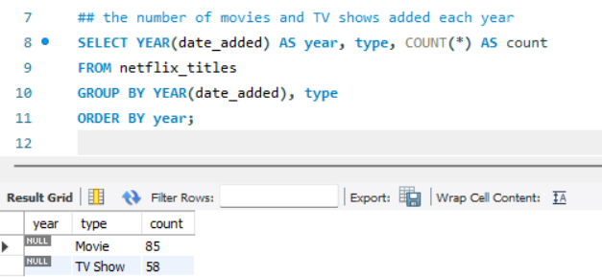
  2. **Country-wise Content Analysis**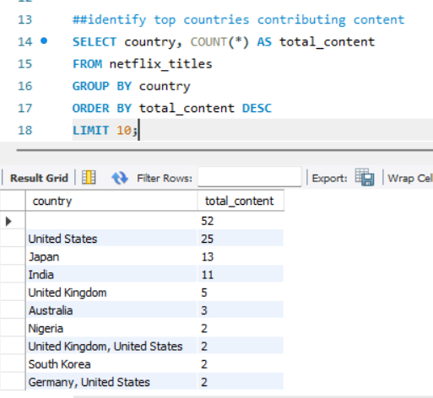

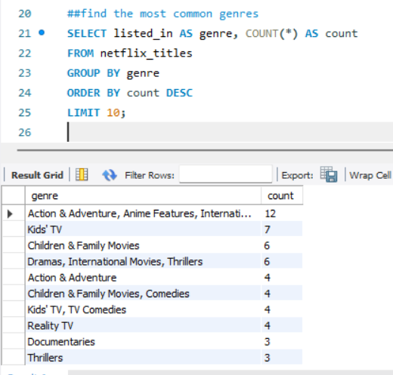

**4 . Ratings Distribution**

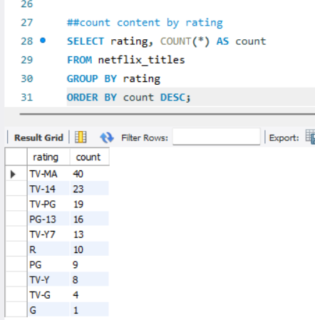

**2. Predictive Analytics**

* **Goal: Predict content ratings or future trends in content production.**
* **Techniques:**
  + **Build simple predictive models using aggregated SQL queries and outputs for further analysis in other tools like Excel or Python.**
  + **Example: Predict the next popular genre based on current trends.**

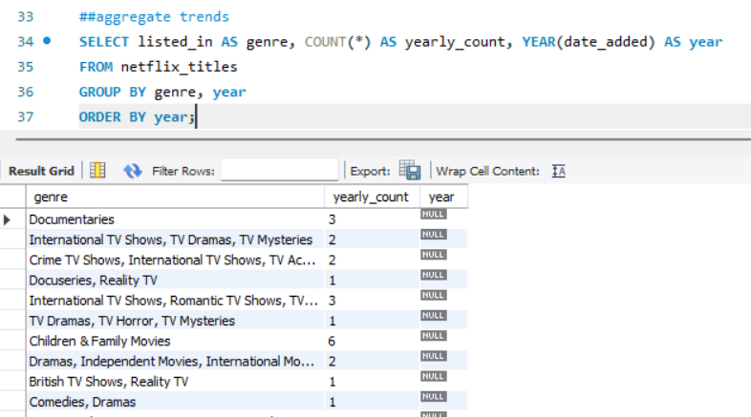

**Prescriptive Analytics**

* **Goal: Suggest actionable recommendations based on insights.**
* **Techniques:**
  + **Content Optimization**

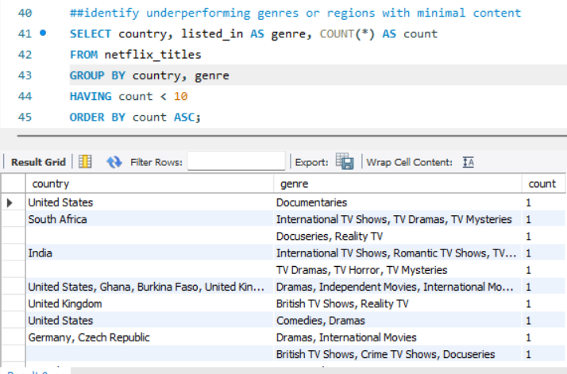

**Recommendation Strategy**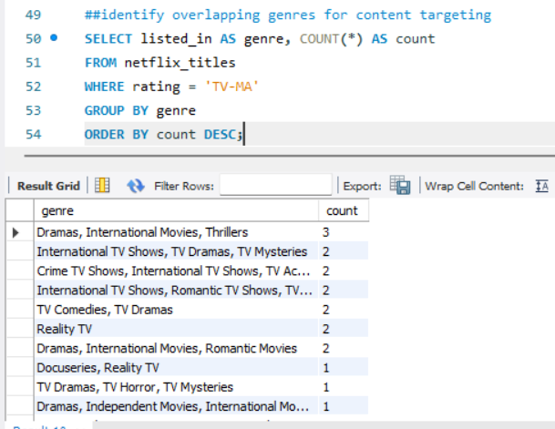

**Methodology**

* **Tool Used: SQL**
  + **Dataset ,SQL , Tableau**
* **Steps:**
  + **Data Preprocessing:**
    - **Load the dataset into an SQL database.**
    - **Clean and format data (handle null values, ensure proper data types).**
  + **Descriptive Analytics:**
    - **Write queries to summarize and visualize data.**
  + **Predictive Analytics:**
    - **Use SQL to aggregate trends and export data for further modelling if needed.**
  + **Prescriptive Analytics:**
    - **Optimize content strategies using SQL insights.**

**Analysis and Results**

* **Descriptive Analysis:**
  + **Identified top genres (e.g., Dramas and Documentaries).**
  + **Found significant growth in content post-2015, with TV-MA content leading ratings.**
* **Predictive Analysis:**
  + **Aggregated trends indicate growing popularity for localized content in emerging markets.**
* **Prescriptive Analysis:**
  + **Suggested increasing investment in international content from underrepresented countries and genres.**
* **Key Insights:**
  + **Dramas and Documentaries dominate the content landscape.**
  + **Countries like the USA and India are top contributors.**

**Conclusion and Recommendations**

* **Key Takeaways:**
  1. **Focus on producing popular genres like Dramas, Documentaries, and Comedies.**
  2. **Expand content offerings in regions with limited availability.**
  3. **Use trends to guide future content acquisitions.**
* **Recommendations:**
  1. **Localize content for emerging markets.**
  2. **Increase collaboration with directors from top-performing countries.**
  3. **Use recommendation systems to enhance user satisfaction.**

**Thank you**

**ANAMIKA SINGH**

**Anamika.s1026@gmail.com**